Outdoor Classroom Day
Media Pack

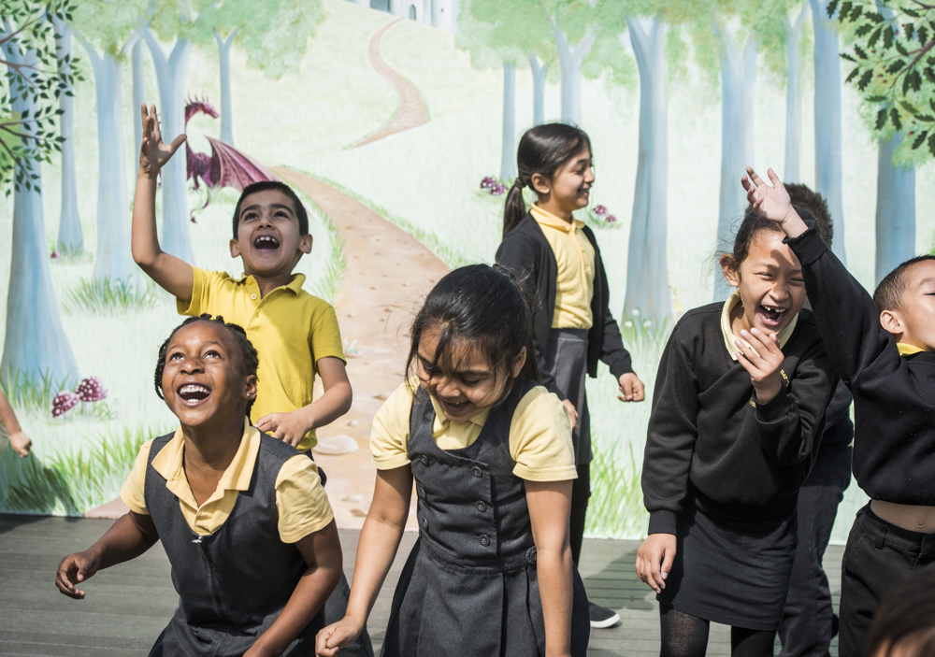

“Research including our Muddy Hands report shows that children who spend time outdoors have better mental health, are more physically active and are more resilient.”

Carley Sefton, CEO of Learning through Landscapes

Contents
1. Campaign overview
2. Biographies
3. FAQs
4. Images
5. Contact details
Campaign overview
Outdoor Classroom Day is a global campaign to inspire and celebrate outdoor learning and play. On the day, thousands of schools around the world take lessons outside and prioritise playtime. As well as having fun, they show how important and easy it is to give children more time outdoors.
So that schools can participate on a day that fits with their climate and term times, the global campaign has two dates each year – check the website for future dates: www.outdoorclassroomday.org.uk
When teachers take learning outdoors, they report some powerful impacts: children’s behaviour improves, whole classes are excited to learn, and individuals who feel inhibited by the curriculum often thrive in an outdoor environment.
When adults think back to their own happiest memories of childhood, they frequently recall the joy of playing outdoors. Play is not only central to children’s enjoyment of childhood, but teaches critical life skills such as problem-solving, teamwork and creativity.
The campaign is about more than just one day; it is a catalyst to inspire more time outdoors every day, both at school and at home. To achieve this, the campaign has three aims: outdoor learning is part of every school day for every child; every child has great playtime at school every day for at least 60 minutes, with the longer term aim of 90 minutes; and schools act as advocates for more time outdoors, so that outdoor play becomes part of every child’s everyday life.
Everyone can do something to make sure children experience the benefits of being outdoors. Parents can encourage their child’s school to get involved and take steps towards more time outdoors at home. Businesses can become campaign partners and think about how they can support local projects that support children’s play. Anyone who cares about childhood can help spread the word about the importance of outdoor play and learning.
In the UK and ROI this autumn’s theme is STEM (Science, Technology, Engineering and Maths) and the campaign will be featuring some great lesson ideas and resources to help teachers lead these subjects. However, schools will be undertaking a wide range of activities showing how easy and fun it is to learn outdoors- whatever the subject and weather!
Whatever you do, join the movement today: www.outdoorclassroomday.org.uk
The global Outdoor Classroom Day is led by Semble (formerly Project Dirt and a founding member of the campaign), in partnership with Unilever as part of their Dirt is Good movement. The UK and ROI campaign is led by Learning through Landscapes, with support from Persil.
Biographies
Carley Sefton, CEO of Learning through Landscapes
Carley Sefton is passionate about the importance of being and learning outdoors. It was at Oasis Community Learning that she gained experience of running a community farm and preschool. There also, she came to appreciate the true scale of the financial challenge many schools face and the drive teachers have to ensure the best outcomes for their students.
Carley joined the team at Learning through Landscapes in 2017. Shortly after, a colleague from another charity who knew LtL well told her: “You have such a tough job. Most people coming into an organisation have the pressure of making it better, you have the pressure of keeping it great!” Carley responded that she had never known an organisation where everyone was an expert in what they did, but at LtL they were.
LtL is the leading UK charity specialising in outdoor learning and play in education. It has trained thousands of practitioners to teach outdoors and has leveraged more than £25 million into schools. Its unrivalled knowledge and expertise are based on three decades of experience of practical action and research. In 2018 it won the National Lottery Environment Project of the Year award for its Polli:Nation project which supported more than 35,000 children and young people to transform their school grounds for the benefit of pollinating insects (and people).
Together with members of its accredited network of freelance outdoor learning experts, LtL has the reach to work and deliver projects in every region of the UK and internationally.
Add your headteacher’s biography here.
FAQs
How did Outdoor Classroom Day start?
In 2011, at the launch of Tim Gill’s Sowing the Seeds report, a group of educators and environmentalists discussed how schools in particular could address the issues that stop children getting outdoors. Their solution was a new campaign they called Empty Classroom Day.
In 2012 a handful of schools in London, England, got involved. By 2015, over 600 schools in 15 countries were involved. As the campaign grew, the volunteers who were running it recognised the need for dedicated investment. So, in 2016, Semble partnered with Unilever’s Dirt is Good team to grow the movement and take it global.
Following consultation with school leaders, play experts and NGOs around the world, the global campaign became Outdoor Classroom Day. There are currently dedicated campaigns running in 13 countries, in addition to a much wider network of schools getting involved in more than 110 countries worldwide!
The campaign’s founder and advisory board member, Anna Portch, continues to be involved in every campaign day, working closely with the UK and ROI campaign.
Who is behind Outdoor Classroom Day?
The global Outdoor Classroom Day is led by Semble, supported by Unilever as part of their Dirt is Good movement. Semble is a social enterprise that connects and resources grassroots community projects, and a founding partner of the original campaign. Unilever is backing Outdoor Classroom Day as part of their core purpose to help parents everywhere make sure that real play is part of every child’s day.
Semble works with respected environmental and educational NGOs around the world to deliver locally relevant campaigns, from Finland to Brazil. In the UK and ROI, the campaign delivery is led by school grounds charity Learning through Landscapes which has been running successful school grounds and outdoor learning campaigns around the world since the 1990s. Like the other NGO partners, Learning through Landscapes is supported by their local Dirt is Good team, Persil, and the experts they work with, to broaden its reach. But really the campaign is delivered on the ground by teachers, parents and supporters! None of us can do this alone.
Is Outdoor Classroom Day just one day?
Outdoor Classroom Day is about more than just one day, it’s a global campaign to inspire and celebrate outdoor learning and play every day. By getting involved in the annual celebrations, teachers help send a message to the world that time outdoors every day is important for every child. They also help to achieve these longer-term shared goals:
- Outdoor learning is part of every school day for every child.
- Every child has great playtime at school every day for at least 60 minutes, with the longer-term aim of 90 minutes.
- Schools act as advocates for more time outdoors, so that outdoor play becomes part of every child’s everyday life.
What are the benefits for taking children outdoors to play and learn?
When teachers take learning outdoors they report some powerful impacts: children’s behaviour improves, whole classes are excited to learn, and individuals who feel inhibited by the curriculum often thrive in an outdoor environment.
When adults think back to their own happiest memories of childhood, they frequently recall the joy of playing outdoors. Play is not only central to children’s enjoyment of childhood, but teaches critical life skills such as problem-solving, teamwork and creativity.
Find out more about the benefits of outdoor play and learning and the difference that Outdoor Classroom Day is making in schools around the world in the Muddy Hands and Playtime Matters reports.
Does the Government back outdoor lessons?
In countries including Australia, Canada and the UK, most state or regional governments formally recognise outdoor learning and break time as beneficial, and in others, like Scotland, they are a requirement. But children are still by no means learning outdoors every day or playing outdoors; either for the minimum hour recommended for physical activity, or for the 25% of school time that some psychological research on mental wellbeing suggests is optimal.
In the UK, the campaign has been discussed in the House of Lords, and received support from members of the Scottish Assembly.
Is it free for teachers to get involved?
Yes! Registration is free and there is even a whole library of free resources such as outdoor lesson ideas and resources for teachers to access on the Outdoor Classroom Day website.
What do teachers get when they sign up?
Teachers get to put their school on the Outdoor Classroom Day map and become part of the global movement for more time outdoors every day. If they opt in, they receive regular campaign emails with resources, inspiration and information to help them get outdoors on the day and all year round.
Should teachers sign up for every campaign day?
Yes! The more schools that get involved in the campaign each year, the more noise we make for our longer-term shared goal that outdoor play and learning are made a key part of the school day.
How can non-teachers get involved?
They can spend some time outdoors on the day and share their experiences on social media using the hashtag #OutdoorClassroomDay.
Nurseries, kindergartens, after-school groups, play organisations youth groups, or even universities can sign up as a ‘school’ and add a note about who they are in the ‘What are your plans for the day?’ box.
Parents of school-aged children can use the ‘letter to parents’ on the campaign website to ask their child’s school to sign up. They could take their children outside after school on the day as well and sign up via the parent tab for additional information and inspiration.
Individuals who work for organisations that believe in the power of outdoor learning and play can get involved by helping to spread the word about the campaign. The ‘supporter pack’ on the campaign website provides ideas and resources.
Images
Visit the Outdoor Classroom Day media image library for a selection of photos you have permission to use with your story. Please note that these images can only be used to promote Outdoor Classroom Day. ADD LINKS/ATTACH PHOTOS FROM YOUR SCHOOL IF YOU HAVE A SELECION WITH PERMISSION TO USE FOR MEDIA WORK.
Contact
For further information and to arrange an interview with a spokesperson, please contact ADD MEDIA LEAD NAME AND CONTACT DETAILS HERE. To arrange an interview with Carley Sefton, Learning through Landscapes CEO, please contact ukandireland@outdoorclassroomday.com

