EMBARGOED UNTIL 00:01 Thursday 17th May 2018

“NOT ENOUGH CHILDREN LEARNING AND PLAYING OUTSIDE”
A call from more than eight out of ten (81%) UK teachers on Global Outdoor Classroom Day 2018

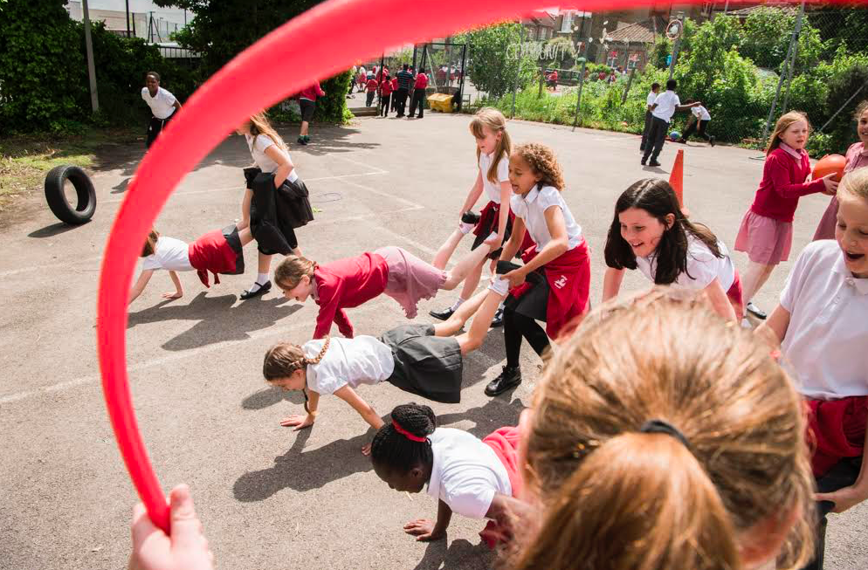

Today, global Outdoor Classroom Day returns, with over 1.2 million children and young people around the world and more than 260,000 in the UK and Republic of Ireland (ROI) participating in outdoor lessons and play. However, national education charity, Learning through Landscapes (LTL) and Project Dirt, highlight in a new report that more than eight out of ten (81 per cent) teachers in the UK don't think there is enough learning outdoors and there should be more.

More than eight out of ten (81 per cent) teachers across the UK said they’d like to take their classes outside more often and nearly half (45 per cent) blame not doing so on the pressures of the curriculum. Despite 64 per cent of schools taking lessons outdoors more than once a week, just over half (58 per cent) of teachers in the UK blamed the weather for stopping outdoor learning.

Outdoor play was also a feature of the research which showed that while over half (55 per cent) of UK teachers thought that there should be more playtime in schools, our children actually enjoy more than others around the world. Shockingly, the survey revealed that two-fifths (40 per cent) of US Primary Schools provide less than half an hour a day, and more than four-fifths (89 per cent) get less than an hour. Two-fifths (40 per cent) of the UK’s Primary Schools get more than an hour of playtime a day, not including time to eat lunch.

Following the Government’s recognition of the importance of time outdoors in the DEFRA 25 year environmental plan launched earlier this year, with £10 million in funding to support outdoor activities, Outdoor Classroom Day highlights there’s still much progress to be made.

Maths was the UK teachers’ favourite lesson to take outdoors last year, so it’s perhaps fortuitous that the Day coincides with the last Maths SATs test of the week for children in Year 6 KS2 in England. As such, teachers and children are encouraged to spend at least 90 minutes outdoors on this day - and every school day - particularly during the exam season, to help maintain mental and physical wellbeing, and reduce anxiety levels.

Spending time outdoors is proven to support positive mental health; with almost all (98 per cent) teachers stating that time spent playing outdoors improves children’s social skills and more than four-fifths (84 per cent) saying that it made children happier. In relation to children developing useful skills to support test performance, three-quarters (75 per cent) of teachers stated that outdoor play improved their children’s levels of concentration and nine out of ten (90 per cent) UK teachers said children engaged more in learning when they spent lessons outdoors.

Spending more time outdoors may be as important for teachers’ wellbeing as that of their pupils. In a previous report on outdoor learning, the Natural Connections partnership with universities revealed that nine out of ten (90 per cent) staff found outdoor learning useful for delivering the curriculum, and more than seven out of ten (72 per cent) said that taking lessons outdoors was good for their own mental wellbeing.

Globally, children in more than 100 countries including France, Spain, Portugal, Brazil, USA, Canada South Africa and Thailand, are joining forces to celebrate the Day. In addition to championing play, teachers will lead a wide variety of lessons including outdoor Maths, English and Science, gardening and eco projects, outdoor-cooking, mindfulness, den-building, Art and Drama, tree climbing and much more.

Sir David Attenborough, Learning through Landscapes Patron, commenting on tarmac playgrounds in a recent film about school grounds, said:
“Natural outdoor environments can offer a very special kind of learning experience: the opportunity for discovery and learning through touching and feeling, the chance to explore and take risks, the stimulations of the fresh air and limitless skies. And yet, we are steadily depriving our children of these wonders. This is why the quality of the last remaining external environment to which many children have frequent access: the school grounds, is so important. Barren tarmac playgrounds may have been sufficient for my generation with freedom to roam, but times have changed and so too must our attitude to these vital spaces.”

Sir Ken Robinson, Author and Educator speaking about the importance of play and raising its profile through initiatives like Outdoor Classroom Day, said:
“Play helps children to learn and experiment, to focus and concentrate, be more self-directed, and to build social confidence. Getting out and breathing- that’s what Outdoor Classroom Day is about.”

Carley Sefton, CEO of Learning through Landscapes said:
“Increasing the time children spend outdoors learning and playing is a free and practical way to address a time-bomb of childhood health and wellbeing issues. What’s more, it helps to enhance engagement in learning across the curriculum and enables children to develop positive relationships with the natural environment. In this week, more than any other, when children are taking SATs or other tests, it is critically important that we enable them to develop the skills to handle the pressures they may experience. Outdoor Classroom Day is a call for teachers, schools and parents to join us in celebrating the benefits of daily outdoor learning and play. ”

Last year, one in five (22 per cent) of the schools that took part in Outdoor Classroom Day said they have increased the amount of outdoors playtime since participating, and just under half (44 per cent) have increased time for outdoor learning. They also tell us that as they increase time outdoors, parents and other teachers at the school get more supportive to committing time outdoors.

Teachers can register their school at www.outdoorclassroomday.org.uk Parents and supporters can also sign up to get posters and letters to encourage schools they know to get involved.

-ENDS-

Notes to editors
For more information or images, or to request interviews, please contact:
Claudia Moselhi on 07521975756 / claudia@clopr.co.uk
Heather Collins on 07961120176 / heathercollinsj@gmail.com

About the research:
- Report by Learning through Landscapes and Project Dirt was conducted in April 2018, polling 600 teachers globally.
- Waite, S., Passy, R., Gilchrist, M., Hunt, A. and Blackwell, I., (2016). Natural Connections Demonstration Project, 2012–2016: Final Report. Natural England Commissioned Reports

About Outdoor Classroom Day:
Outdoor Classroom Day is a global campaign to inspire and celebrate outdoor learning and play. On the day, thousands of schools around the world take lessons outside and prioritise playtime. As well as having fun, they show how important and easy it is to give children more time outdoors. When teachers take learning outdoors they report some powerful impacts: Children’s behaviour improves, whole classes are excited to learn, and individuals who feel inhibited by the curriculum often thrive in an outdoor environment. When adults think back to their own happiest memories of childhood, they frequently recall the joy of playing outdoors. Play is not only central to children’s enjoyment of childhood, but teaches critical life skills such as problem-solving, teamwork and creativity.

The campaign is about more than just one day; it is a catalyst to inspire more time outdoors every day, both at school and at home. To achieve this, the campaign has three aims: Outdoor learning is part of every school day for every child; every child has great recess/playtime at school every day for at least 60 minutes, with the longer-term aim of 90 minutes; Schools act as advocates for more time outdoors, so that outdoor play becomes part of every child’s everyday life.

The global Outdoor Classroom Day is led by Project Dirt, in partnership with Unilever as part of their Dirt is Good movement. In the UK and Ireland, Learning through Landscapes is supported by Persil to deliver the campaign.

In the UK and Ireland Outdoor Classroom Day will be on 17 May. There will be a second opportunity to take part on 1 November.
www.outdoorclassroomday.org.uk

About Learning through Landscapes
Learning through Landscapes was founded in 1990 and helps children to connect with nature, become more active, learn outdoors and have fun. Its transformation of school grounds and teacher training, alongside an unrivalled knowledge and expertise gained through practical action and research has led to its reputation as the UK’s leading school grounds educational charity. While still predominantly working in the education sector LTL’s expertise has now been successfully applied to a number of different fields including dementia care, working with young homeless people and species conservation.
www.ltl.org.uk

About Project Dirt
Project Dirt aims to resource thousands of grassroots community projects, and to capture and share the stories of those achievements. Its online platform enables successful relationships to be formed between the business and community sectors. Project Dirt's mission is to create a vibrant and active online community where individuals, communities, companies and local authorities can share knowledge, advice, best practice and access resources.

Project Dirt was one of the founding partners of the Outdoor Classroom Day (then called Empty Classroom Day), set up and run by teachers, educators and environmental campaigners. We work with an Advisory Board including other founding partners, leading academics and NGOs from across the world. info@outdoorclassroomday.com https://outdoorclassroomday.com/about/
www.projectdirt.com

About Dirt is Good
Dirt is Good (DiG) is the campaign supported by Unilever’s leading detergent brands including OMO, Persil, Skip and Via, sold in over 78 markets. We believe that by getting dirty, children develop, learn and grow through rich memory-making experiences. These experiences often come in the form of ‘real play’: play that is free, exploratory and sometimes messy, allowing children to enjoy the present and thrive in the future. Our vision is to create a play-friendly world so that all children everywhere can experience play every day. Whether known as OMO, Persil, Skip, Breeze, Ala, Wisk, Surf or Rinso in your part of the world, you can trust we’ll be there with the superior technology needed to help your family remove those tough stains again and again, so you’re able to enjoy those experiences worry-free.

In a recent global study of 12,000 parents, OMO found a stunning statistic: children were spending as little time outdoors as maximum security prisoners. This insight led us to focus our mission on rebalancing children’s lives through real play, especially outdoors. We created a database of activities for kids both indoors and outdoors to inspire fun experiences and collaborated with local organisations in Brazil, Turkey and the UK to create unique adventures for the whole family. Play needs to be a constant throughout a child’s day, as it’s a key way they learn and grow. That’s why we support Outdoor Classroom Day, an initiative we have championed in more than 50 countries to get children all over the world, on the same day, taking at least one lesson outdoors and celebrating the importance of their playtime.
Visit www.outdoorclassroomday.com to learn more and join the fun!

About Unilever
Unilever is one of the world’s leading suppliers of Beauty & Personal Care, Home Care, and Foods & Refreshment products with sales in over 190 countries and reaching 2.5 billion consumers a day. It has 161,000 employees and generated sales of €53.7 billion in 2017. Over half (57%) of the company’s footprint is in developing and emerging markets. Unilever has more than 400 brands found in homes all over the world, including Persil, Dove, Knorr, Domestos, Hellmann’s, Lipton, Wall’s, PG Tips, Ben & Jerry’s, Magnum and Lynx.

Unilever’s Sustainable Living Plan underpins the company’s strategy and commits to:

• Helping more than a billion people take action to improve their health and well-being by 2020.

• Halving the environmental impact of our products by 2030.

• Enhancing the livelihoods of millions of people by 2020.

The USLP creates value by driving growth and trust, eliminating costs and reducing risks. The company’s sustainable living brands are growing 50% faster than the rest of the business and delivered more than 60% of the company’s growth in 2016.

Unilever was ranked number one in its sector in the 2017 Dow Jones Sustainability Index. In the FTSE4Good Index, it achieved the highest environmental score of 5. It led the list of Global Corporate Sustainability Leaders in the 2017 GlobeScan/SustainAbility annual survey for the seventh year running, and achieved four A ratings across Climate Change, Water, Forests and Supplier Engagement in CDP's 2018 Global Supply Chain report. Unilever has pledged to become carbon positive in its operations by 2030, and to ensure 100% of its plastic packaging is fully reusable, recyclable or compostable by 2025. For more information about Unilever and its brands, please visit www.unilever.com
For more information on the USLP: www.unilever.com/sustainable-living/

